**IFT 510: Principles of Computer Information and Technology**

Ankitha Bhavana Gaddam

Activity 1 Install Visual Studio Code and Java Development Extension

Mr. Dinesh Sthapit

February 6, 2023

**Downloaded and Installed Visual Studio Code:**

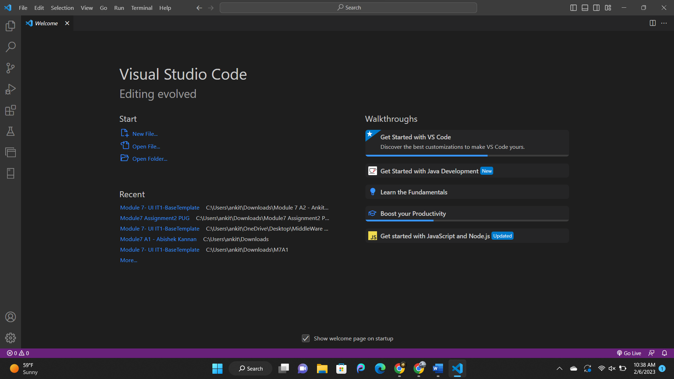

**Downloaded Coding pack for Java:**

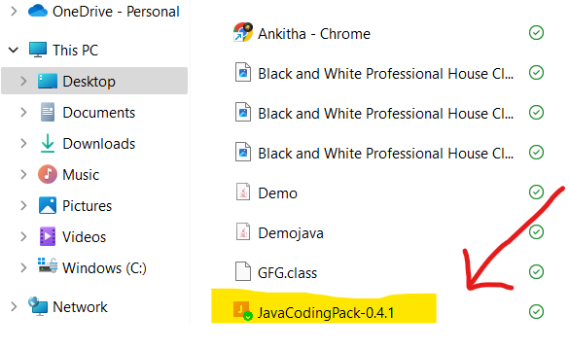

**Downloaded JDK Environment:**

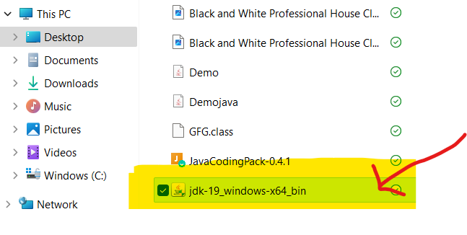

**Visual Studio Code:**

**Source code:**

// Java program to convert a decimal

// number to binary number

import java.io.*;

class GFG

{// function to convert decimal to binary

static void decToBinary(int n)

{ // array to store binary number

int[] binaryNum = new int[1000]; // counter for binary array

int i = 0;

while (n > 0)

{ // storing remainder in binary array

binaryNum[i] = n % 2;

n = n / 2;

i++;

}// printing binary array in reverse order

for (int j = i - 1; j >= 0; j--)

System.out.print(binaryNum[j]);

}

// driver program

public static void main (String[] args)

{

int n = 17;

System.out.println("Decimal - " + n);

System.out.print("Binary - ");

decToBinary(n);

}}

* I have copy pasted the code as mentioned in the assignment in the Visual Studio Code and saved it as NumberSystems with .java extension.

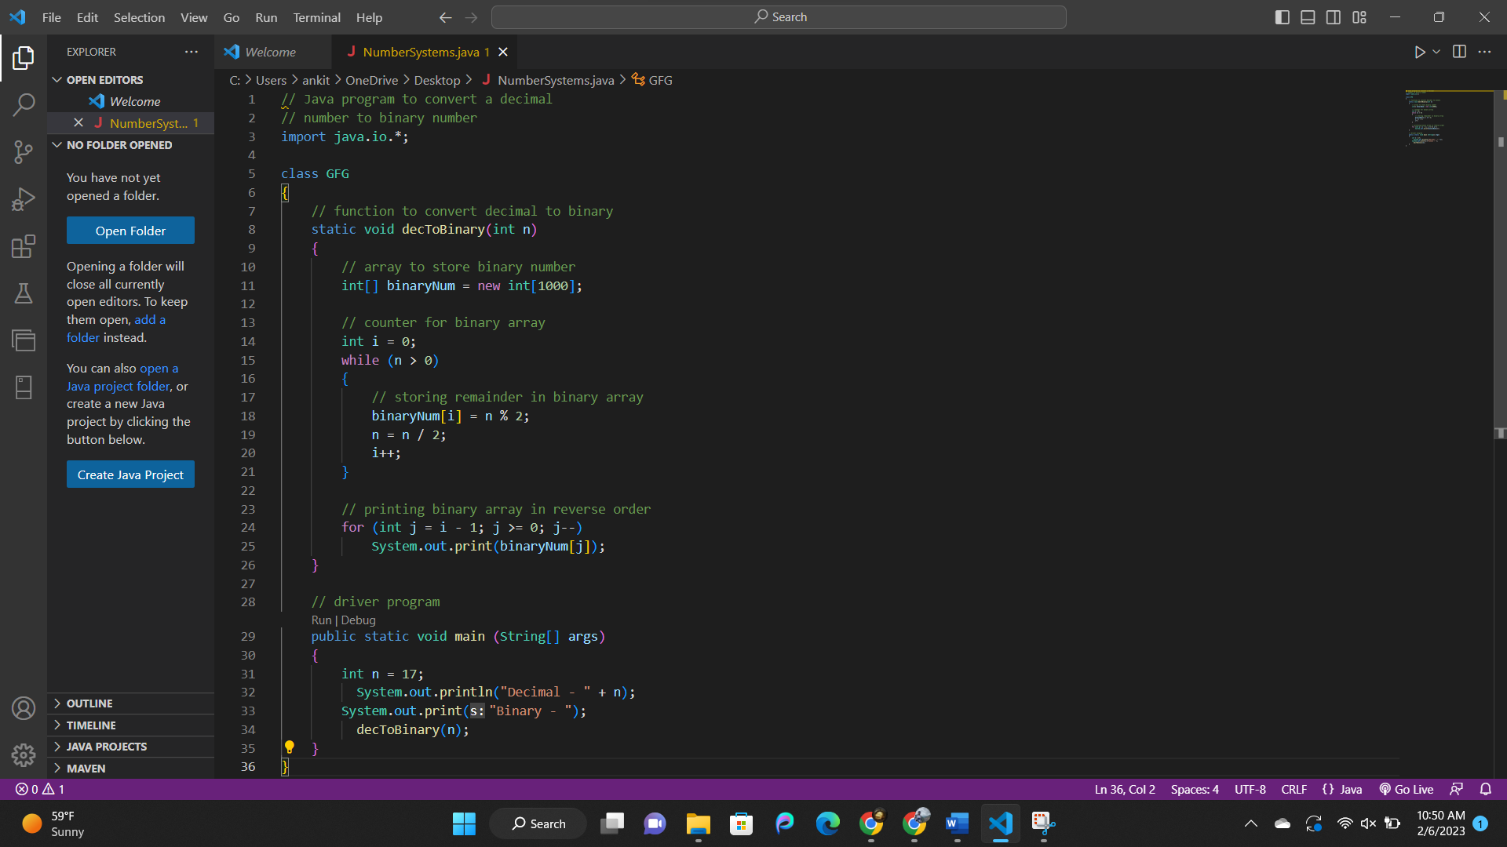

* Now I opened the terminal and executed the code with commands “javac NumberSystems.java” and “java NumberSystems.java”

